Project: Diamond Prices

Complete each section. When you are ready, save your file as a PDF document and submit it in your classroom.

# **Step 1: Understanding the Model**

*Answer the following questions:*

1. According to the model, if a diamond is 1 carat heavier than another with the same cut, how much more should I expect to pay? Why?

Since finding the Price = -5269 + 8413 * carat + 158.1 * cut + 454 * clarity , with the same cut and clarity we need $**8,413 more** .

2. If you were interested in a 1.5 carat diamond with a **Very Good** cut (represented by a 3 in the model) and a **VS2** clarity rating (represented by a 5 in the model), how much would the model predict you should pay for it?

Since finding the Price = -5269 + 8413 * carat + 158.1 * cut + 454 * clarity where;

Carat = 1.5 , Cut = 3, clarity= 5

We find the Price = $10094.8

# **Step 2: Visualize the Data**

Make sure to plot and include the visualizations in this report. For example, you can create graphs in Excel and copy and paste the graphs into this Word document.

1. Plot 1 - Plot the data for the diamonds in the database, with carat on the x-axis and price on the y-axis.

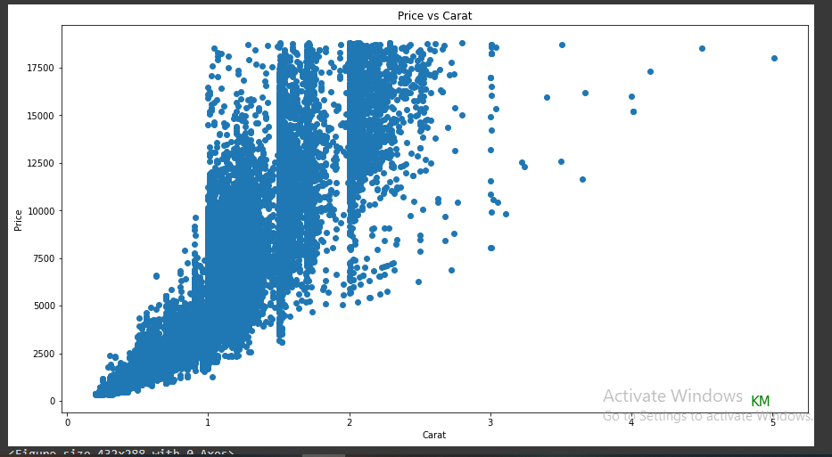

2. Plot 2 - Plot the data for the diamonds for which you are predicting prices with carat on the x-axis and predicted price on the y-axis.

o **Note**: You can also plot both sets of data on the same chart in different colors.

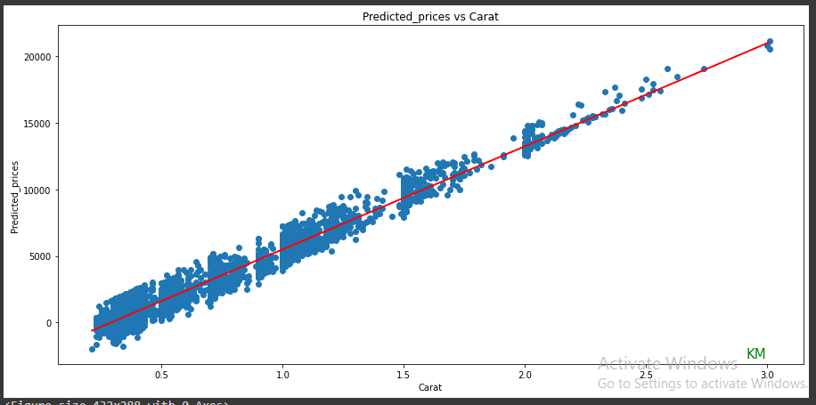

3. What strikes you about this comparison? After seeing this plot, do you feel confident in the model’s ability to predict prices?

* What strikes me is that the model can predict negative values when the carat is less than 0.5 hence more factors should be considered when predicting the diamond prices.

# **Step 3: Make a Recommendation**

*Answer the following questions:*

1. What price do you recommend the jewelry company to bid? Please explain how you arrived at that number.

Do the sum of the predicted prices then apply 70% on the totals. The recommended price is **$8211163.1**